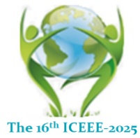
16th ICEEE-2025 Online International Anniversary Conference
“Global Environmental Development & Sustainability: Research, Engineering & Management”
November 20 - 21, 2025
Óbuda University, Budapest, Hungary

Title of the presentation (letter size and type: 16, Cambria)

Author(s) name(s): First name sure name (Letter size and type: 14, Cambria)

Workplace(s), city, country (NO MORE) (Letter size and type: 12, Cambria)

Abstract text should not more than 350 words with letter size and type: 11, Cambria. Please try to follow the instructions.
No figures, no tables and no references.

Abstract text should shortly contain: Background of the problem and aim(s), method(s) used, clear and important results, and ended by conclusion(s)

Please send back through the electronic link

Keywords: not more 6 words (Letter size and type: 10, Cambria)

Biography with new photo

Corresponding address: (Letter size and type: 10, Cambria)
Name: Title (Prof., Dr., Mr., Mrs., or Miss) First name sure name
Department:
Faculty:
University:
Post Address: Zip code, Street, building number
City, Country
Telephone/mobile:
E-mail:
Please, kindly fill the form and return THROUGH THE ELECTRONIC LINK

